[Deep Learning A-Z™: Hands-On Artificial Neural Networks](https://www.udemy.com/course/deeplearning/) - Udemy

Input layer: an input to start the prediction.

Output: a value that we want to predict price, someone leaves the bank, someone stays.

Hidden layer: information comes through the senses, and it goes through billions and billions of neurons before it gets to the output.

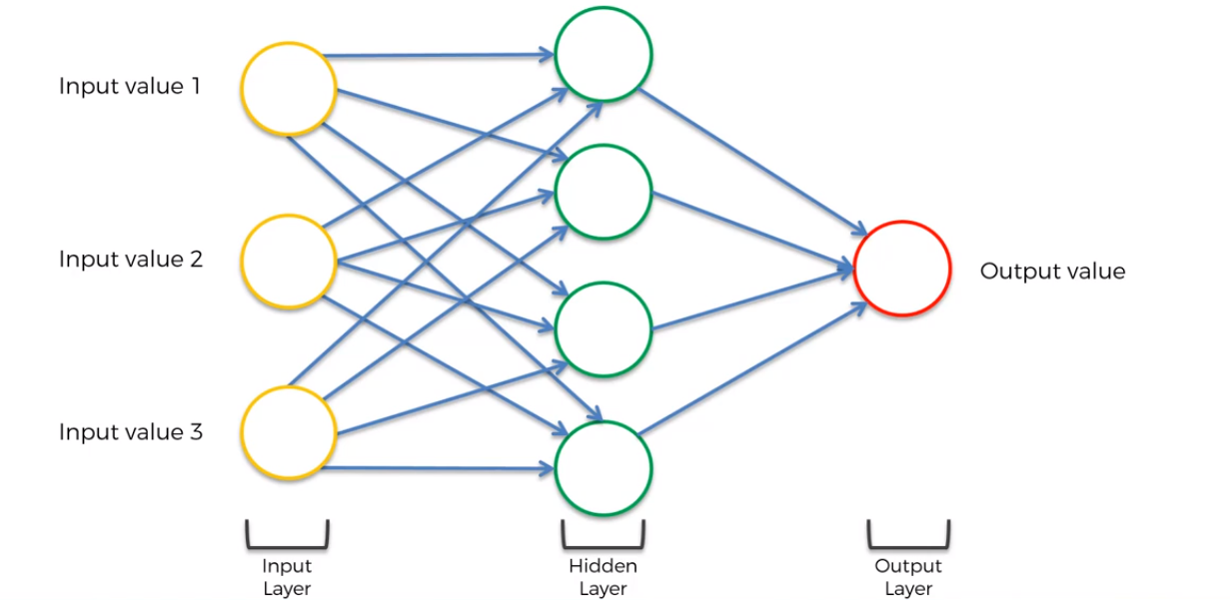

Deep learning: when we have lots of lots of hidden layers (just like a human brain).

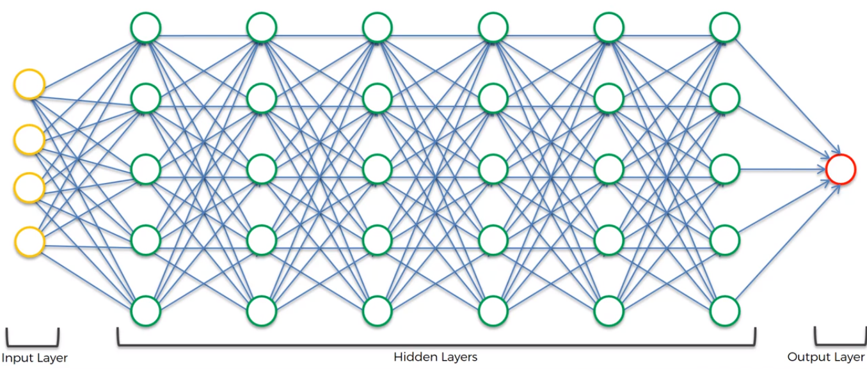

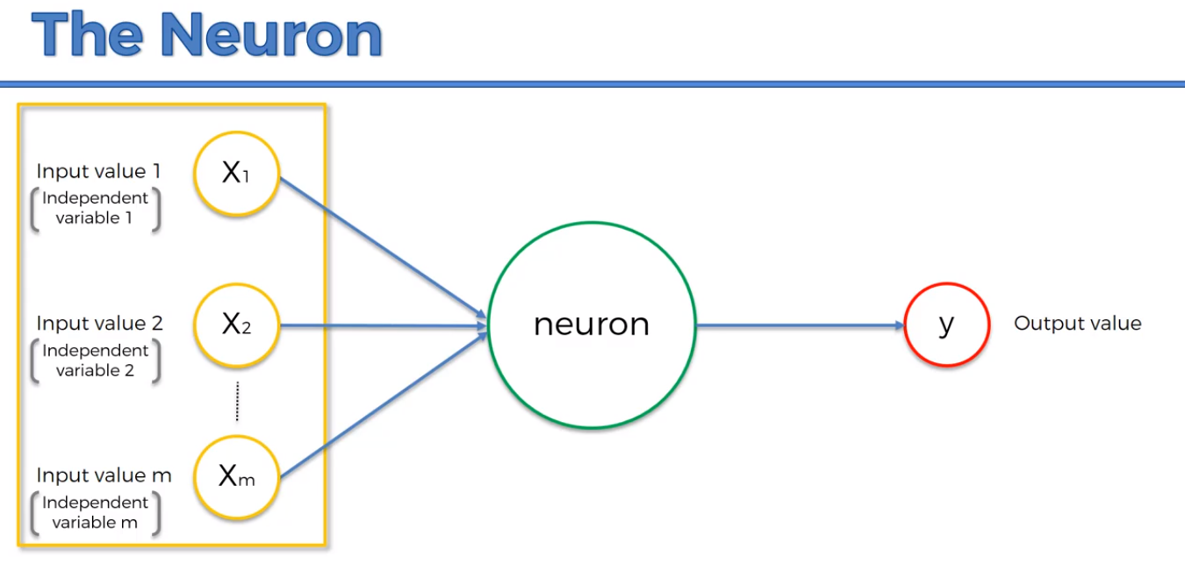

We need to standardize the variables, where they have a **zero mean** and **variance of 1.**

**S**ometimes we want to make them similar (the same range of values), so we do normalization, where we subtract the min value and then we divide by (max – min).

Its going to make it easier for the neural network to process them if they all about the same value, because they are going multiplied and added up several times.

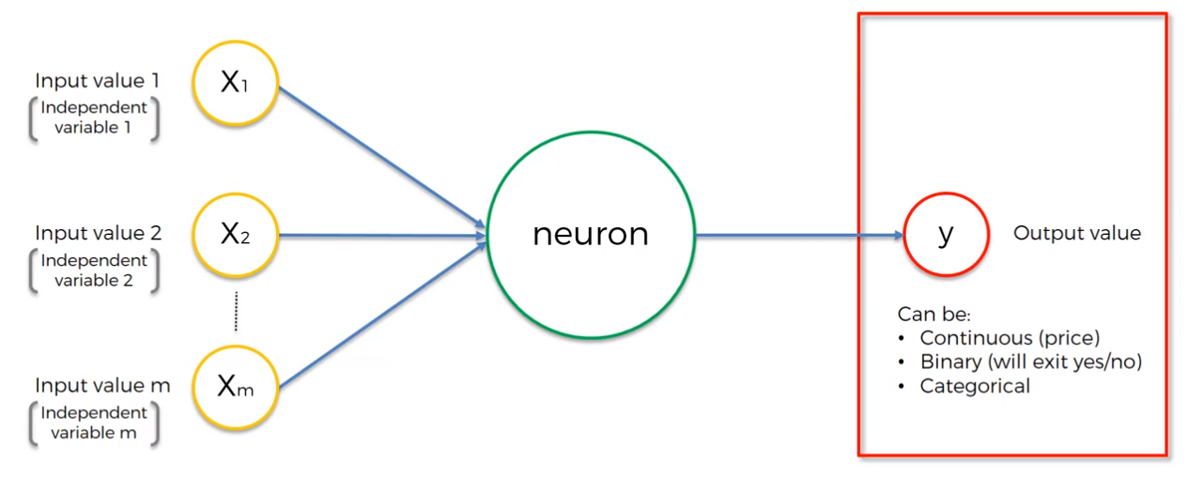

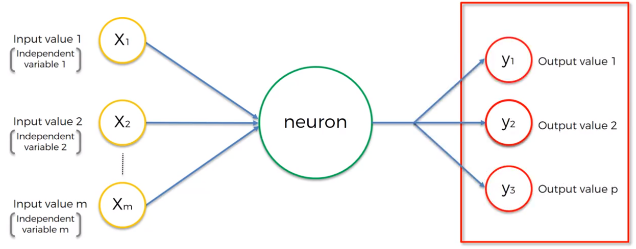

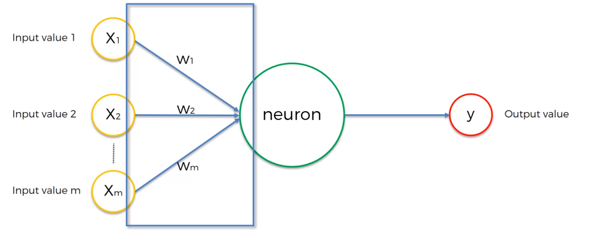

We add the weights then we apply a function Phi:

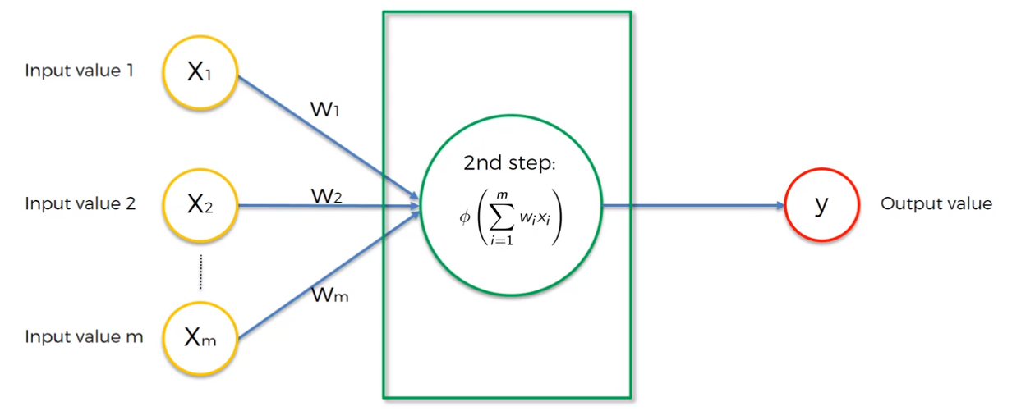

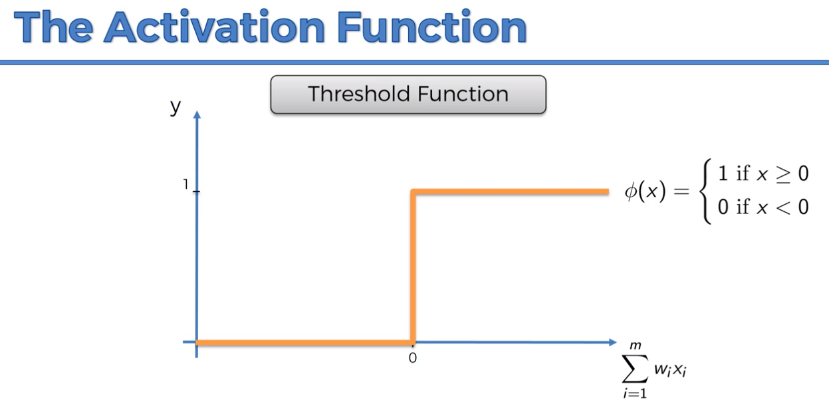

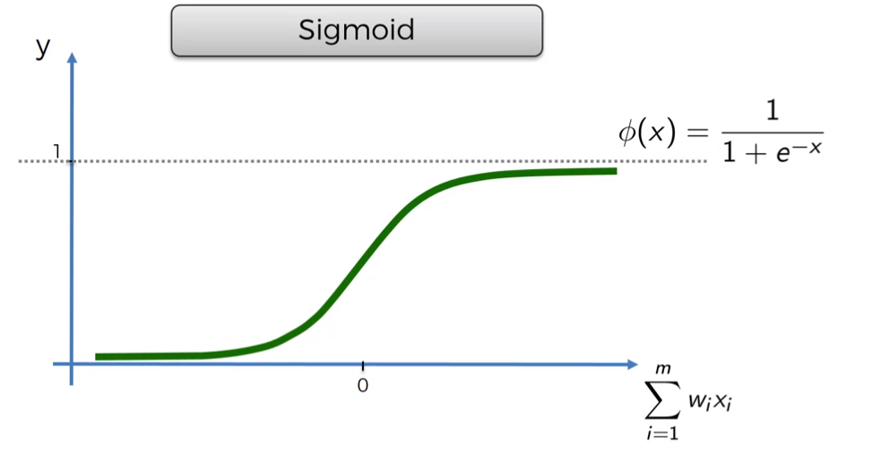

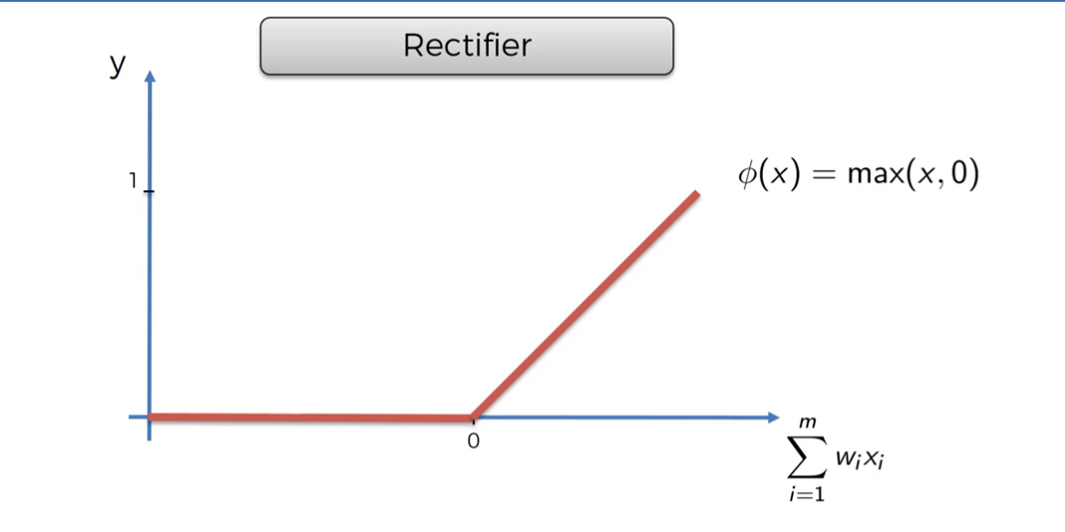

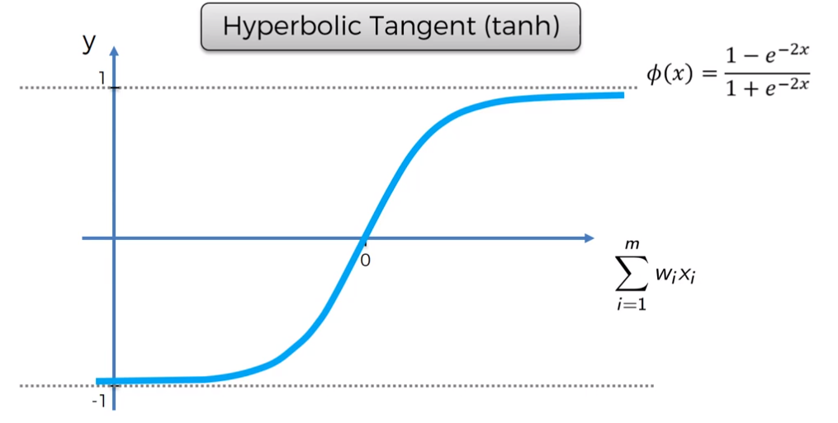

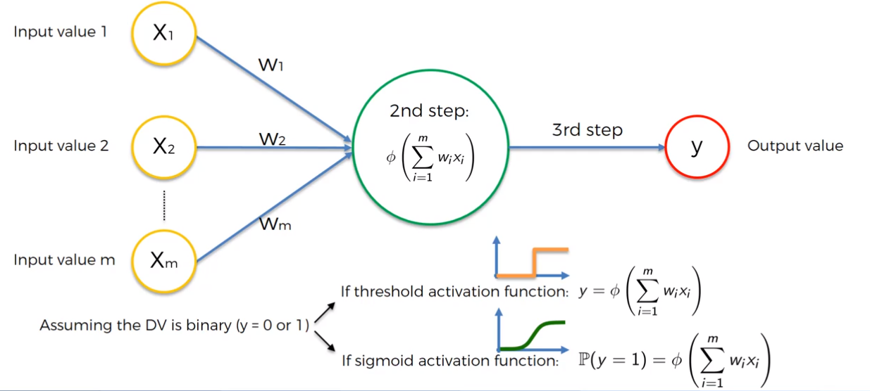

The sigmoid functions tells us what is the probability of $y$ being 0 or 1.

What we will usually do:

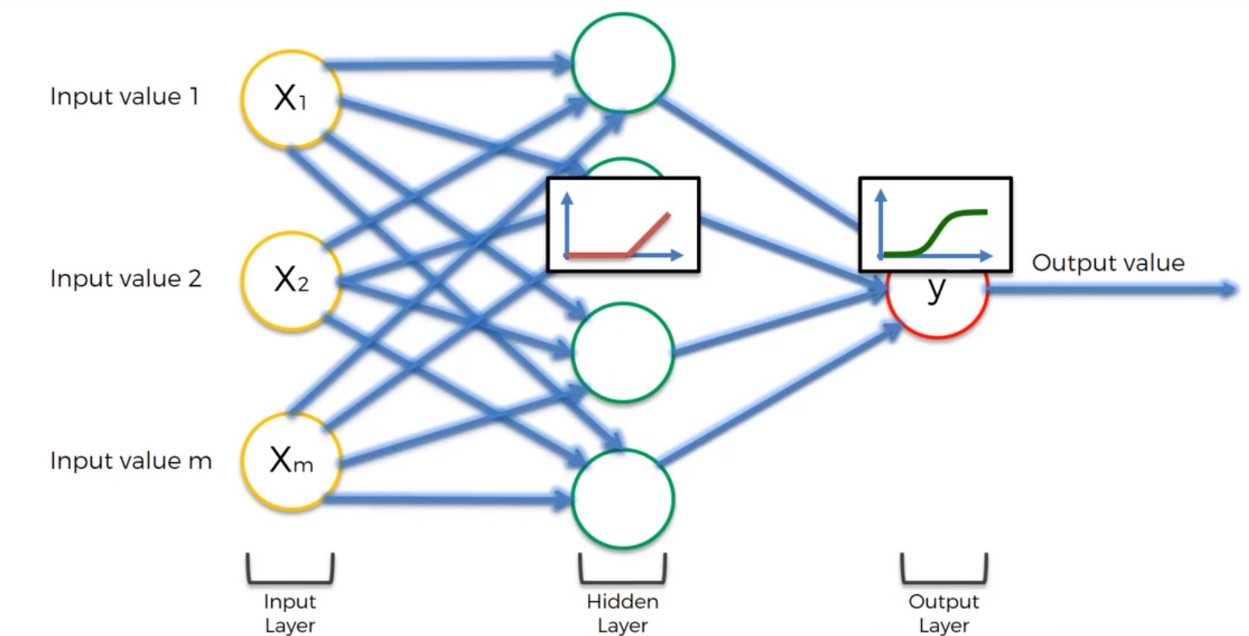

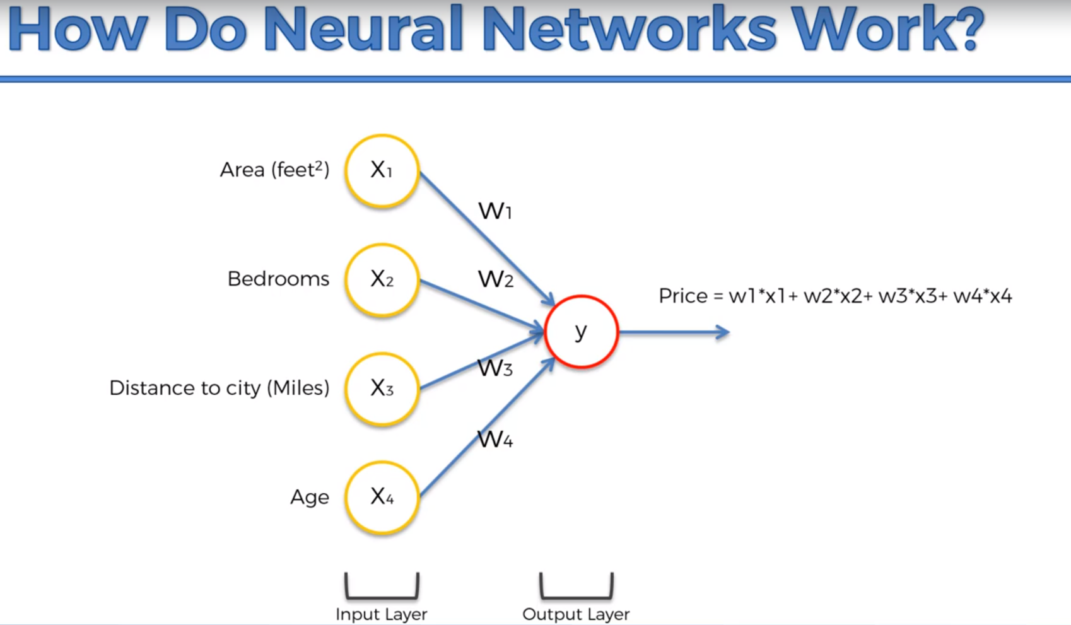

Why would this neuron be only linked to Area and Distance?

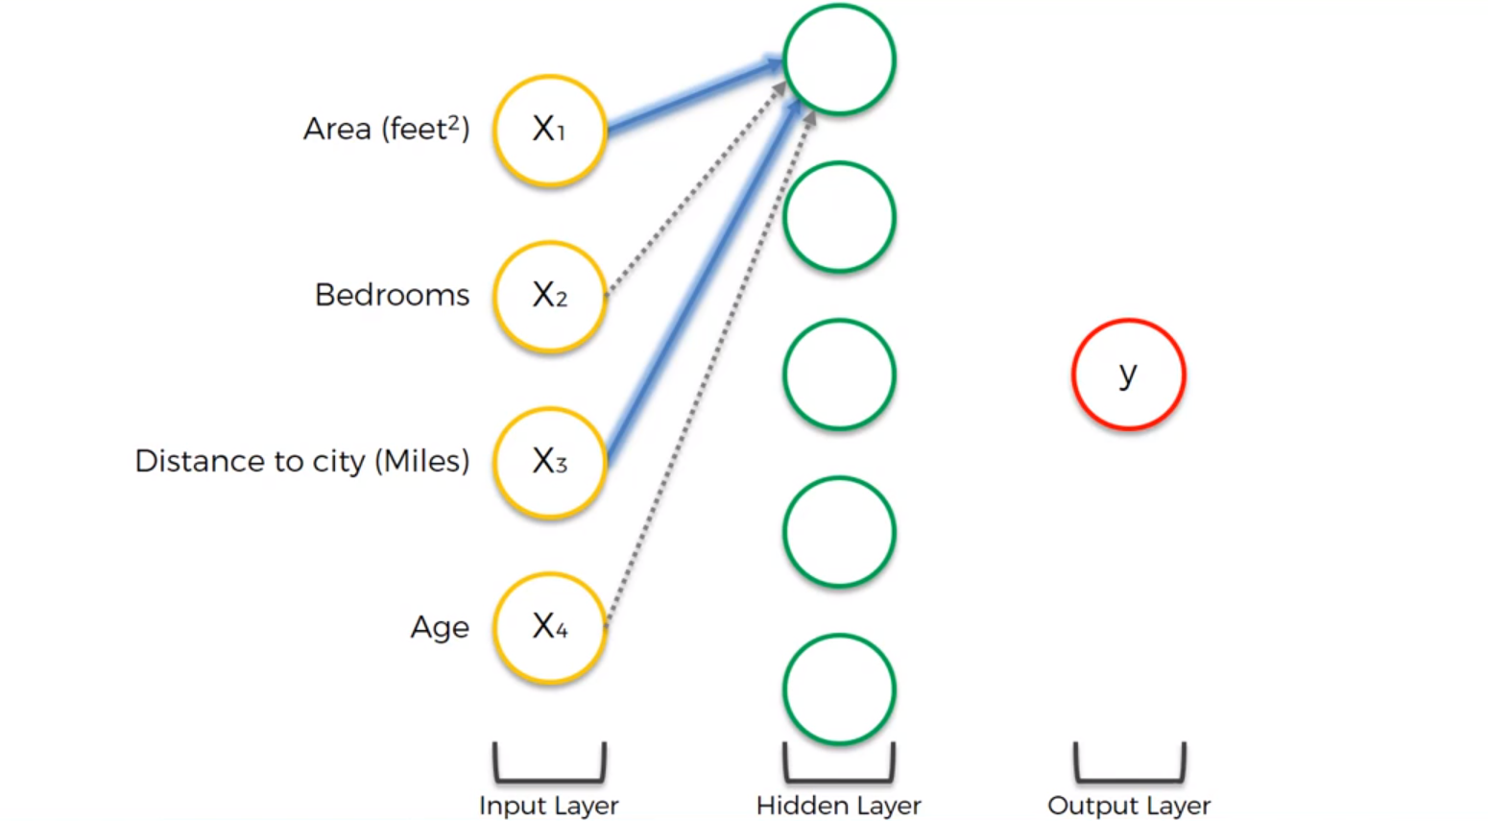

Well that could mean that normally the further away you get from the city,

the cheaper real estate becomes, and therefore the space in square feet of properties

becomes larger. So for the same price you can get a larger property the further away you go from the city. So these synapses will have a larger weight than the other two.

The neuron will fire up, whenever the criteria is met with respect the parameters (Area, Distance).

Therefore, this neuron doesn’t really care about bedrooms and age.

After training, this neuron for example will think that Area + Bedrooms + Age would be important:

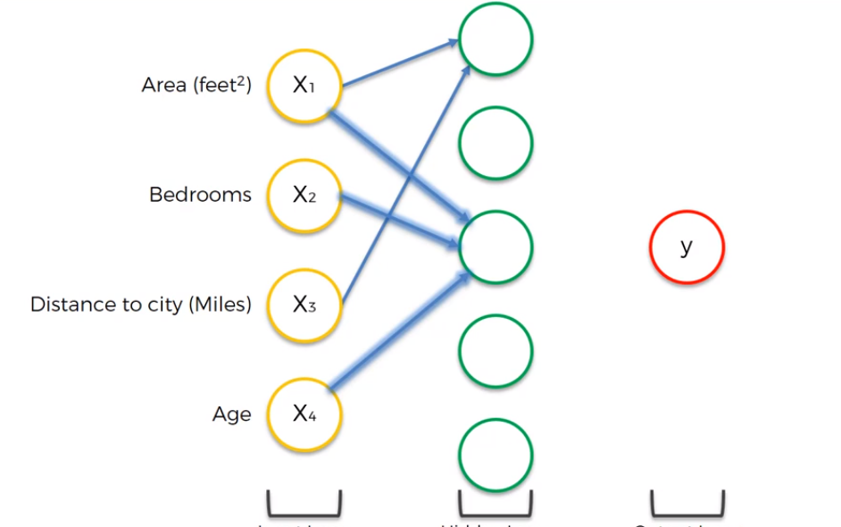

Maybe some families with children prefer a new property (the age of property is lower).

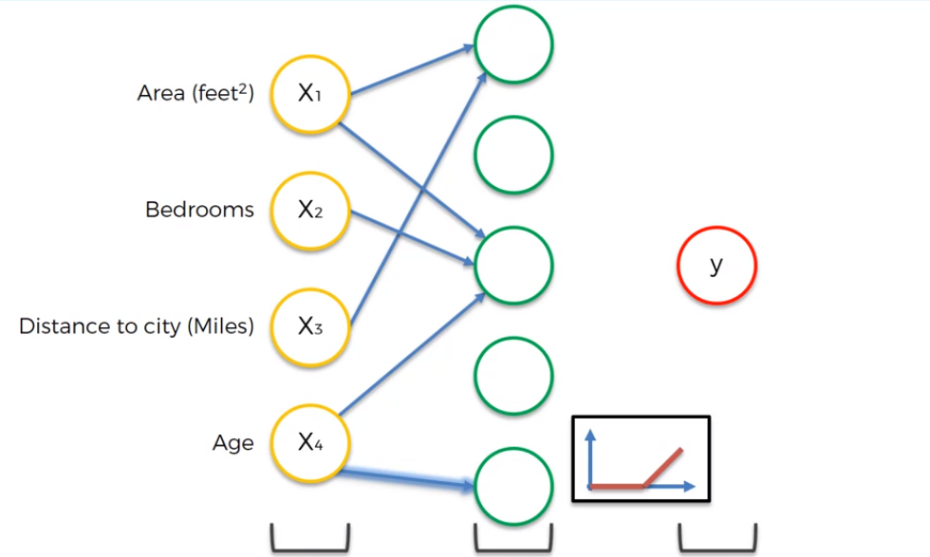

For example: properties that are over 100 years old, could be deemed as historic. That’s a good example where we use the rectifier function.

The neural network would also pick up things we never thought about, for example, bedrooms + distance may for some reason contribute to the price.

This allows the neural network to look for specific things and in combination we can predict the price (just like ants, one ant alone can’t build an anthill, but 1000 ants together can).

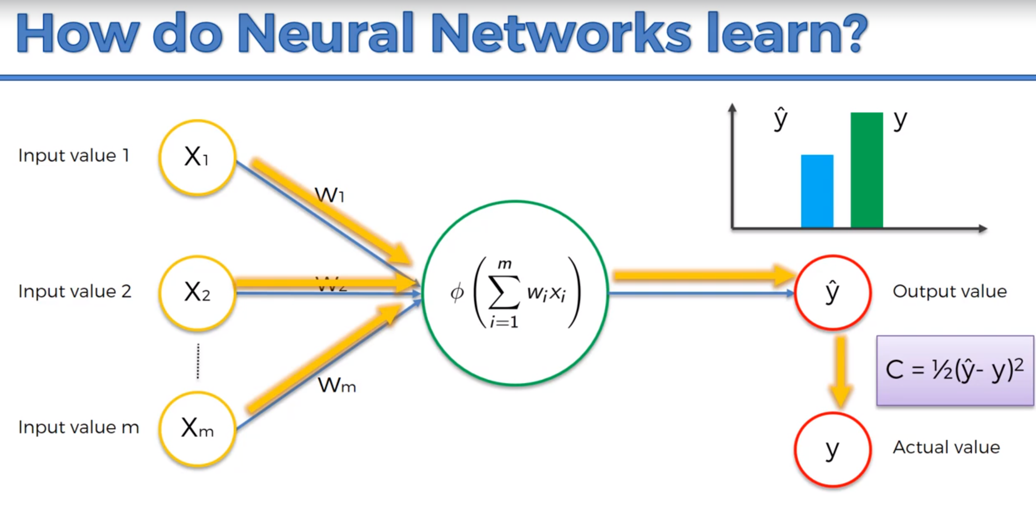

The cost function gives us an information about the prediction error. And our goal is to minimize the cost function.

Now we feed back the result of the cost function to the Neural Network.

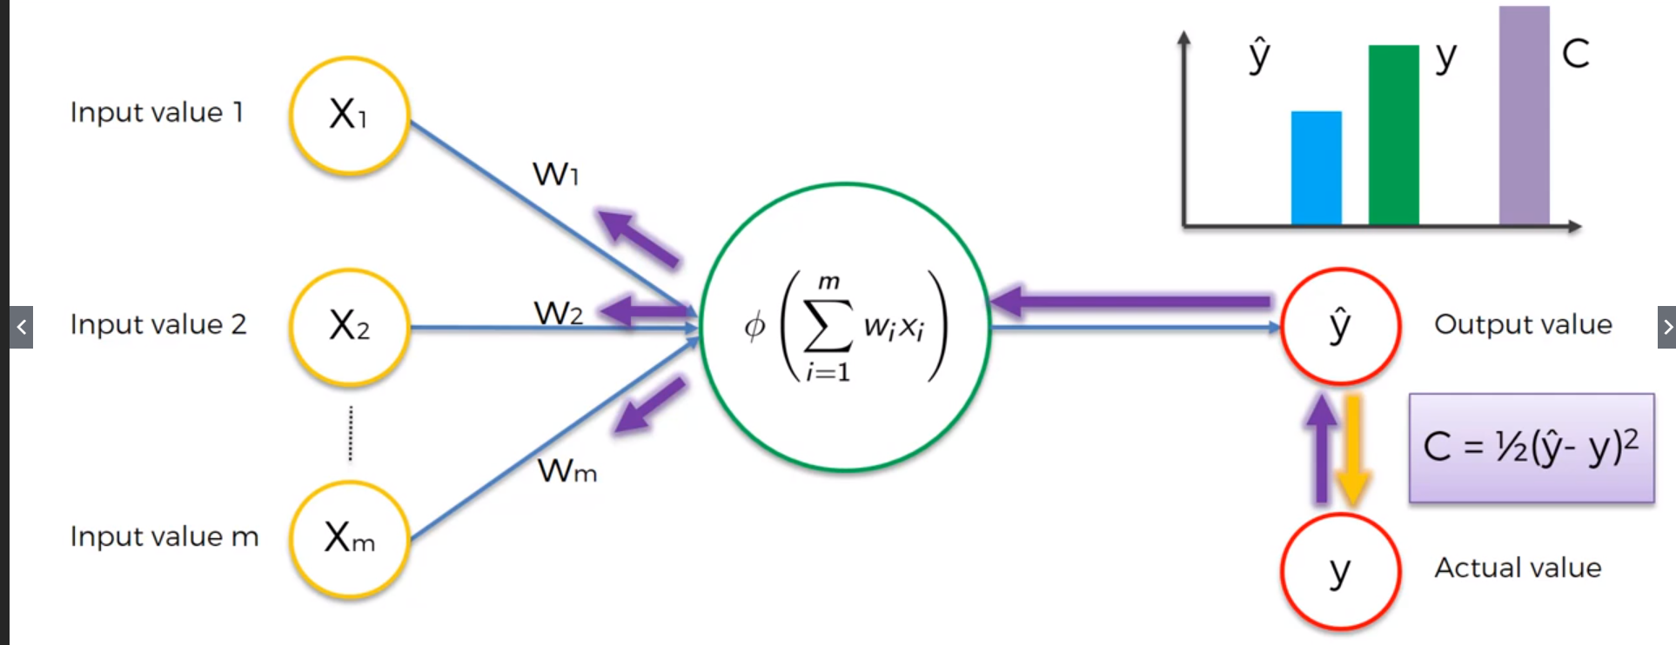

Reminder: right now, we deal with only one row, ex:

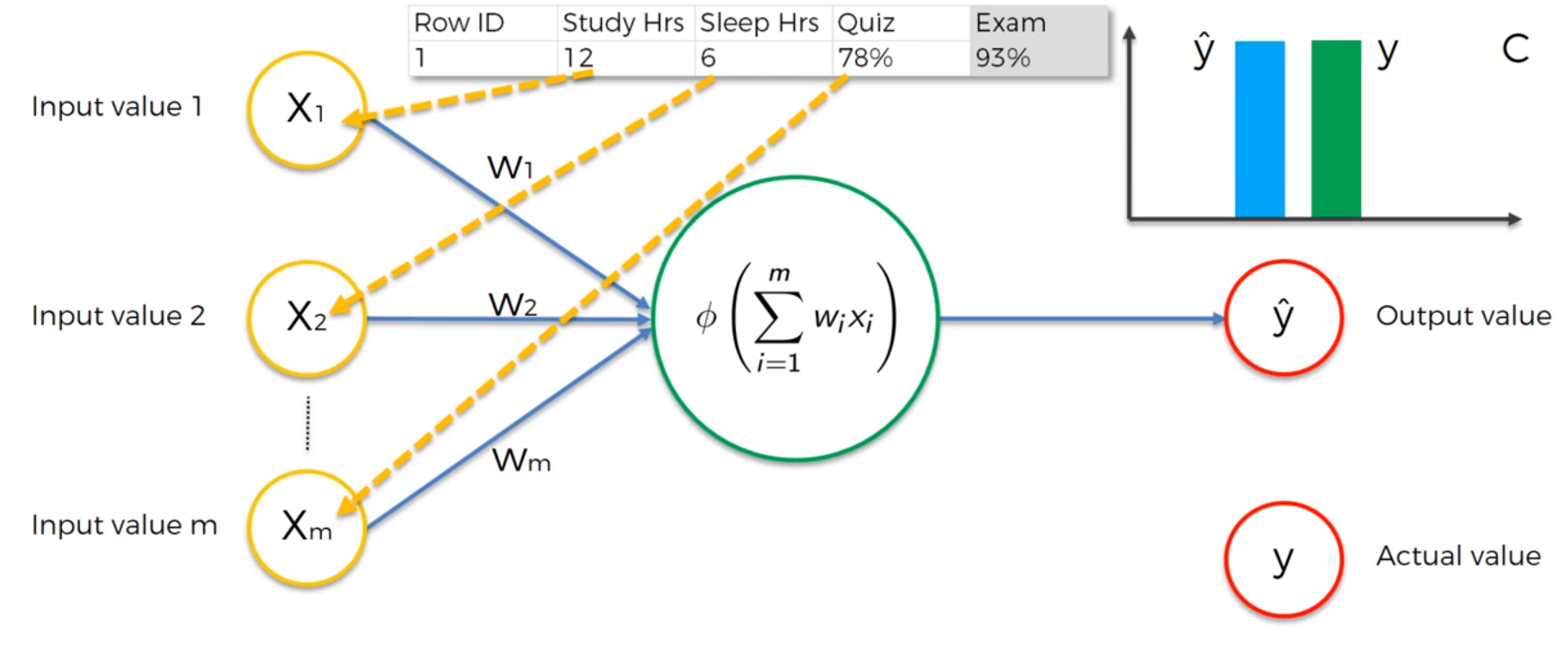Based on these variables we will try to predict what score a student will get on the exam.

Every time $\hat{y}$  is changing, the cost function C also changes.

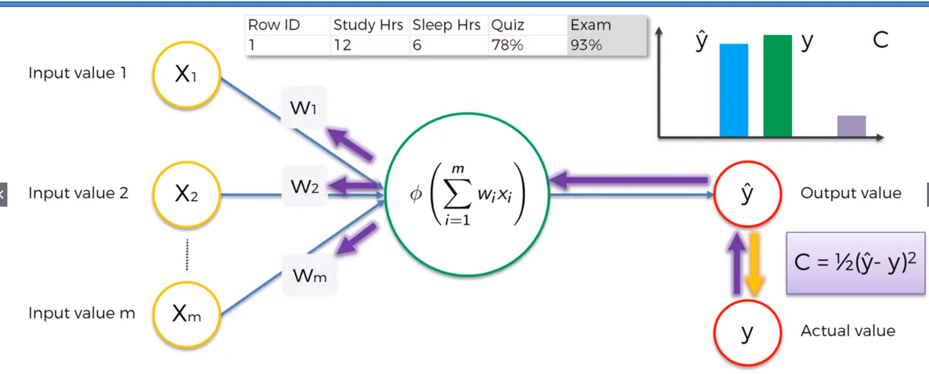

What happens if we have multiple rows?

Every time we feed one row to the neural network:

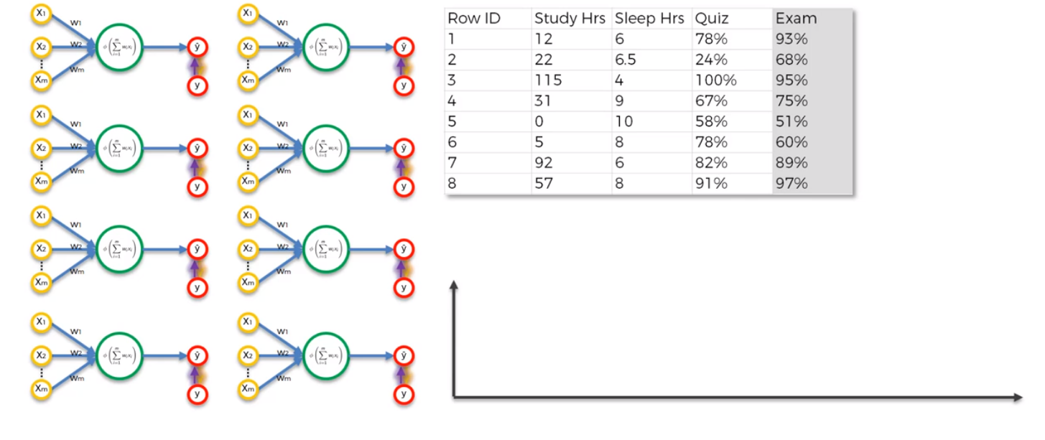One epoch is when we go through the whole dataset and we train our network on all of these rows.

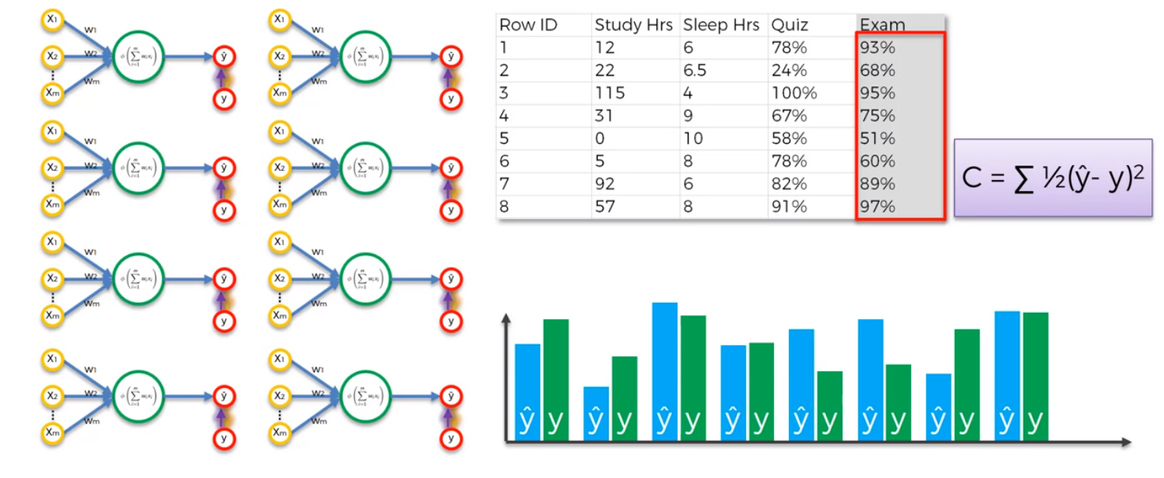

The Breen Bars are the actual values $y$ (Exam Column) – these exist in out training set.  
The Blue Bars represent the prediction for each row.

Where going to do what we did before for the 8 rows (feed the cost function result back to the network)

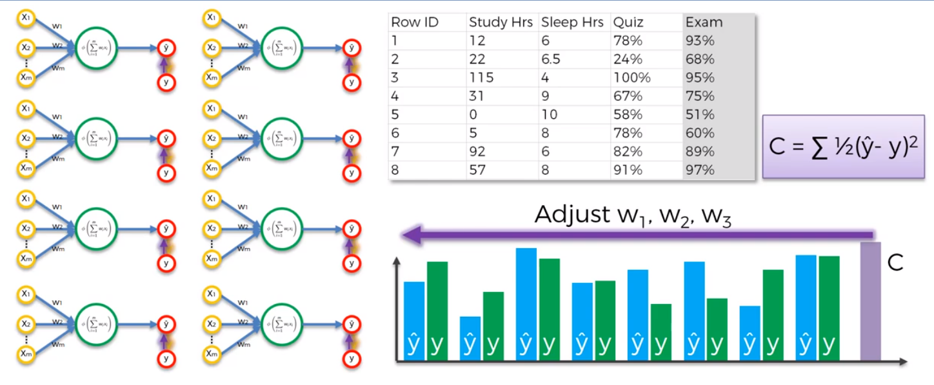

All of these 8 rows are one neural network, all the rows share the weights.

This is called back propagation, where the error C is back propagated to the neural network and the weights are adjusted accordingly.

How these weights are adjusted?

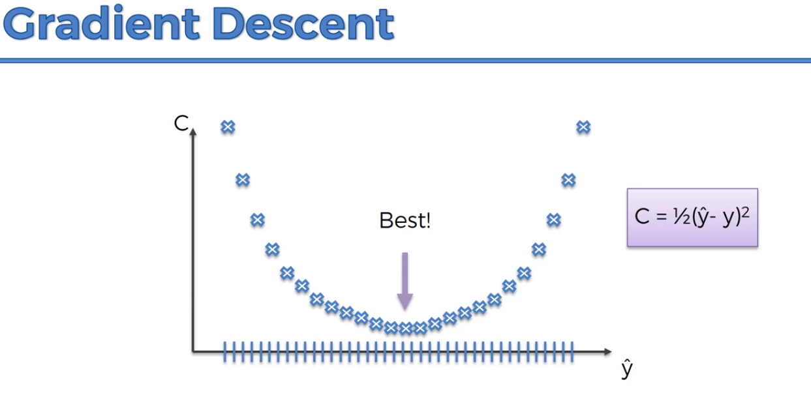

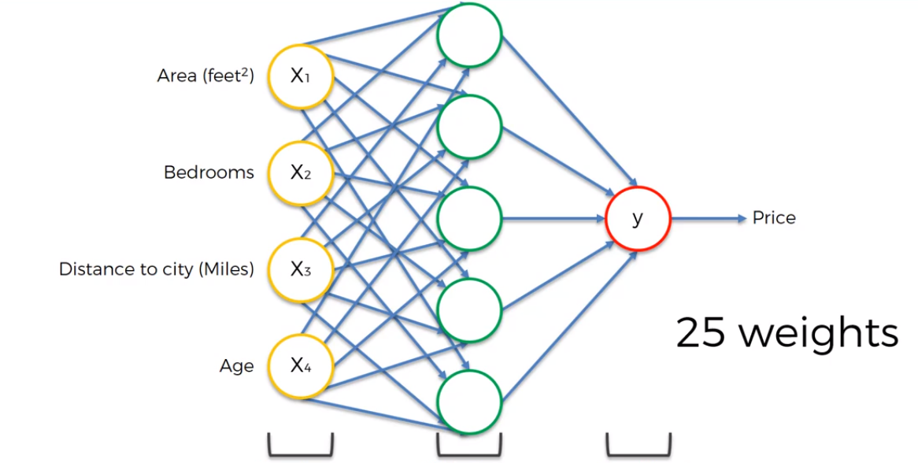

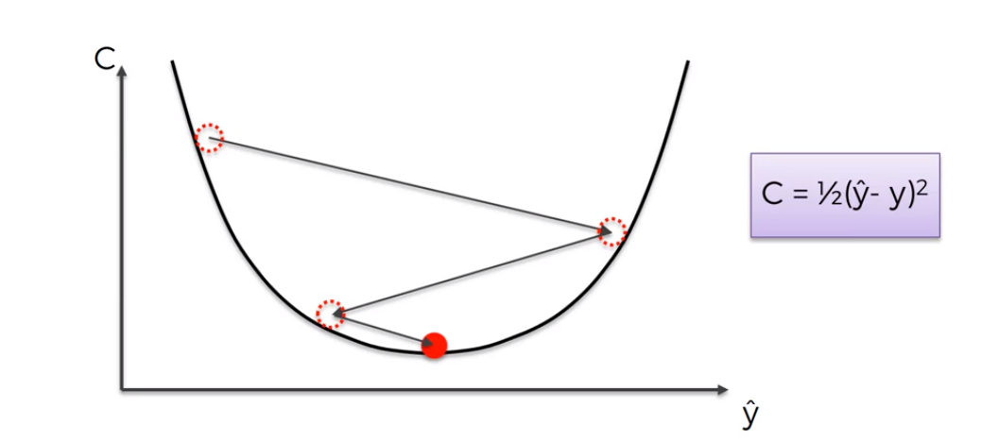

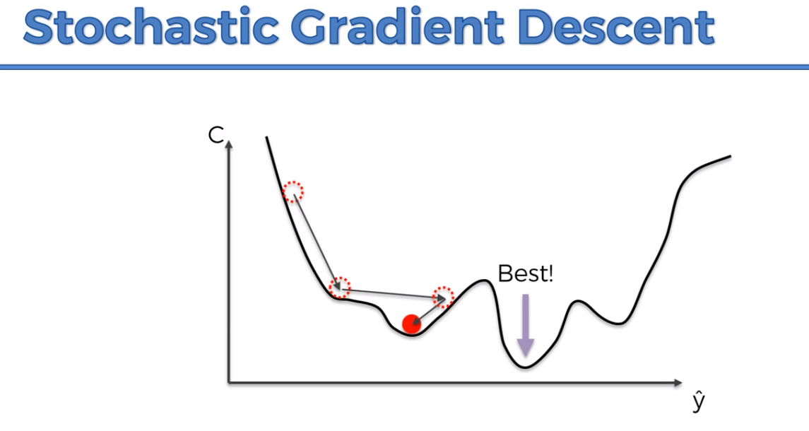

It doesn’t require the function to be Convex.

Difference between Gradient Descent and Stochastic Gradient Descent:

**Gradient Descent**: when we take all the rows and we plug them into the neural network, and we adjust the weights at the end.

**Stochastic Gradient Descent:** we take one row, run the NN, and then we adjust the weights, we take second row, adjust the weights, and so on.

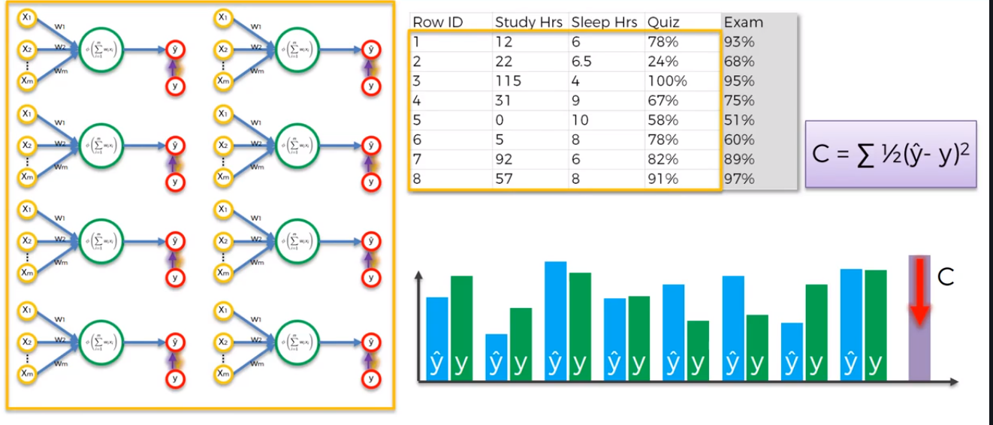

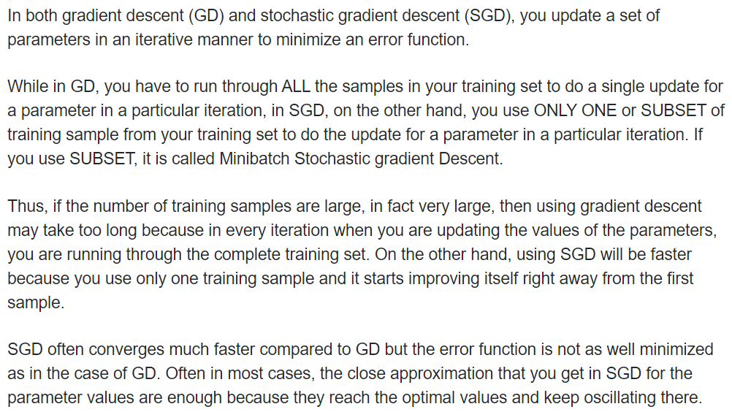

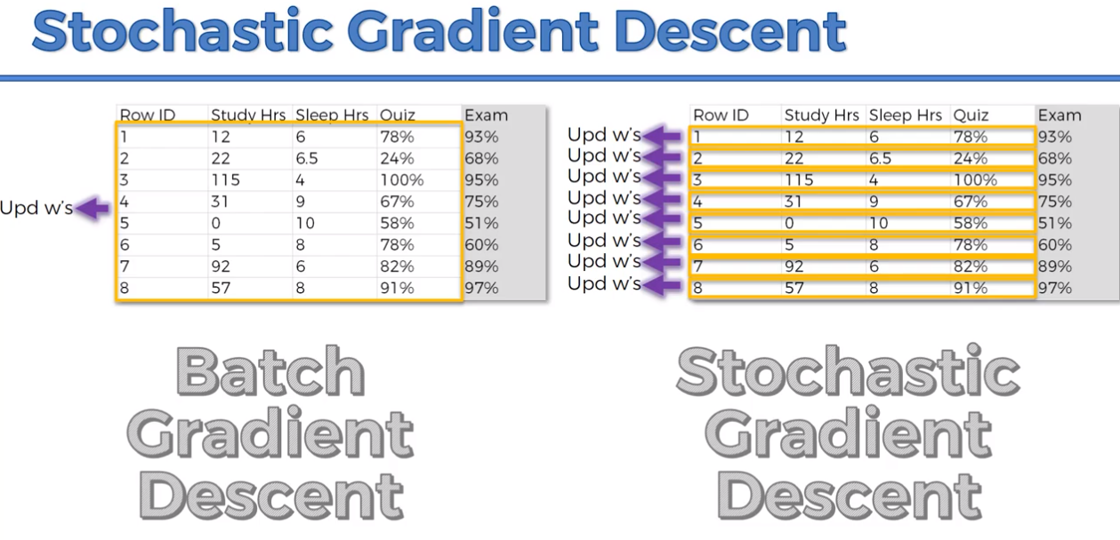

The stochastic gradient descent method helps us avoid the problem of having local min. because SGD had much higher fluctuations, and thus it has a higher probability of finding local minimum.  
  
SGD is faster since it doesn’t need first to load up all the data into the memory and wait until all these rows are run together.

The main pro for GD is that it’s a deterministic algorithm rather than stochastic gradient descent which is random.

**Mini-batch Gradient Descent:** is when we runbatches of rows (combination between Stochastic and Batch GD)

<http://iamtrask.github.io/2015/07/27/python-network-part2/>

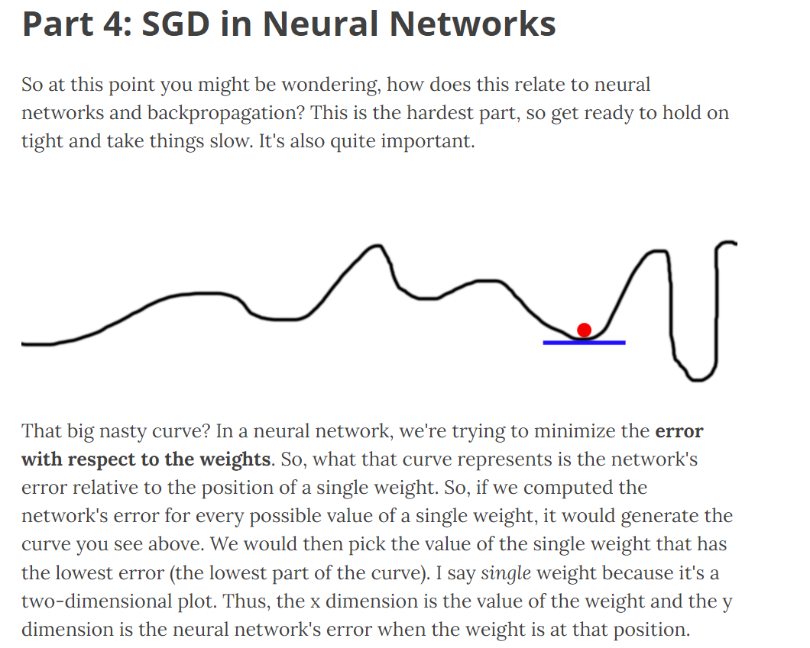

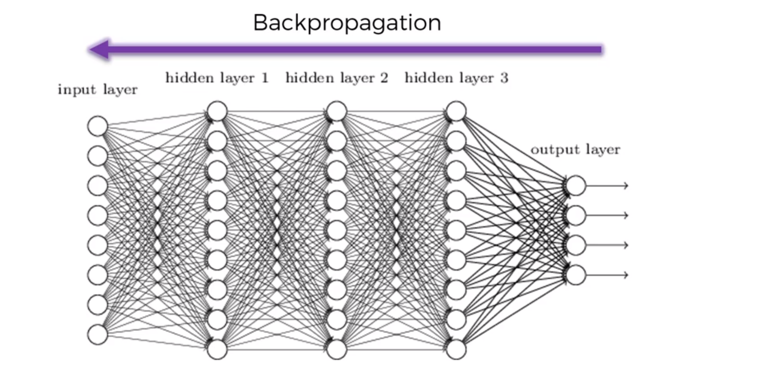

Backpropagation adjust all the weights at the same time.

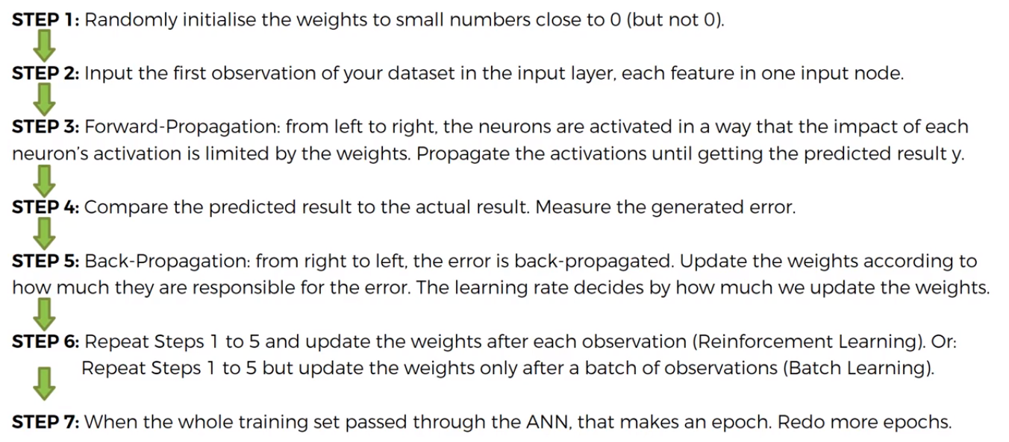

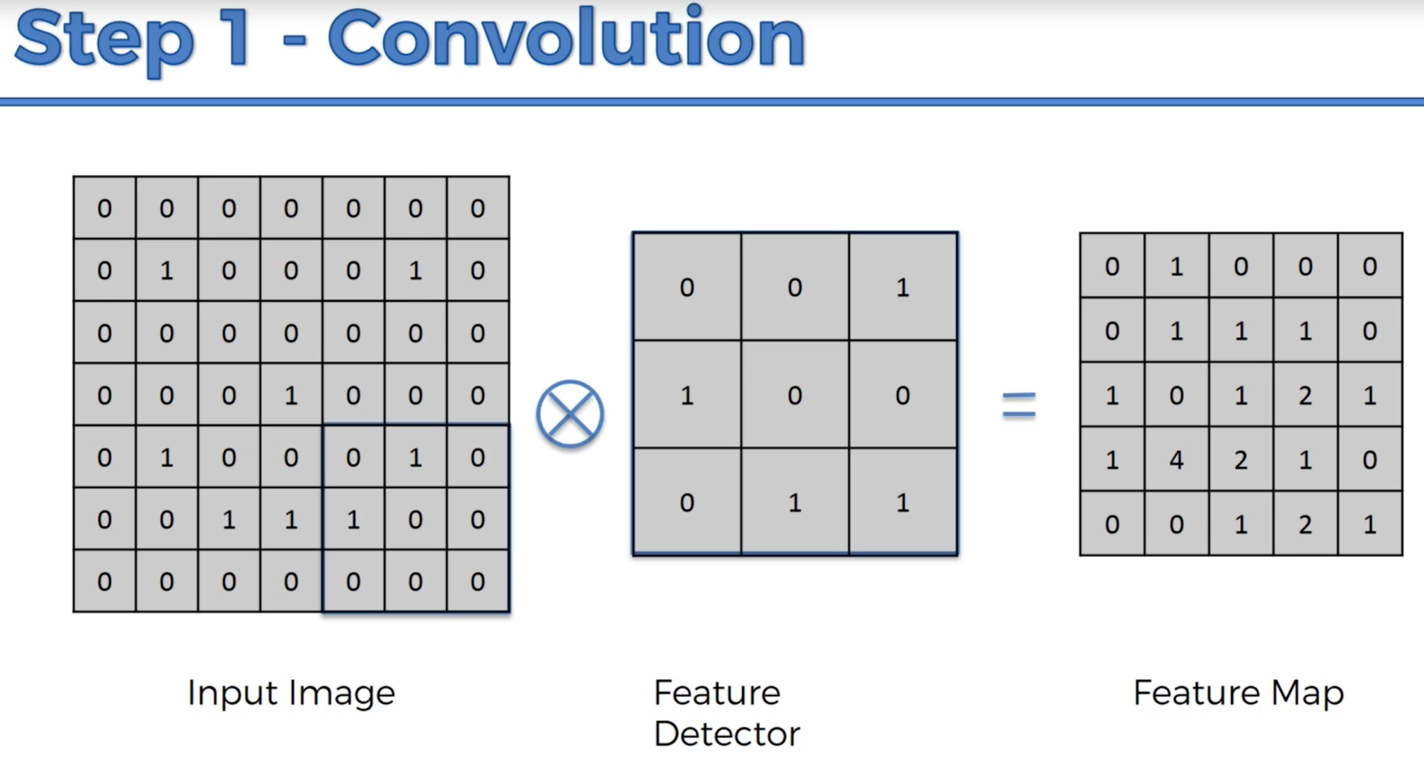

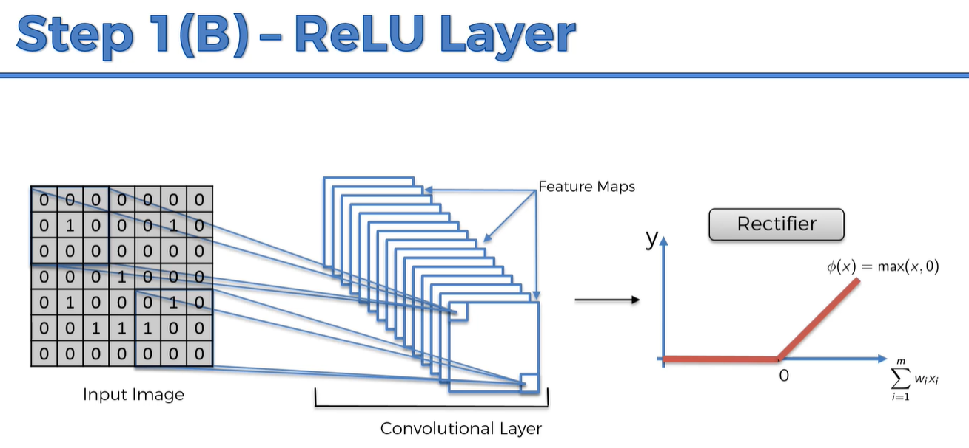

We consider the conv and rectifier as one big step.

The reason why we are applying the rectifier is because we want to increase non-linearity in the convolutional neural network.

The reason we want to increase non-linearity in our network is because images themselves are highly non-linear, especially if we are recognizing different object.

Using some Conv might create something Linear and therefore we need to break up the Lienarity.

Example:

This is a Linear progression in colours: white, grey, black.

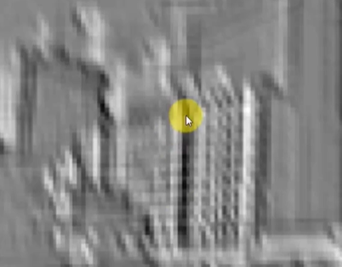

When we take out the black, we break up the linearity:

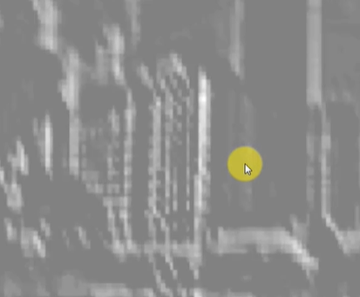

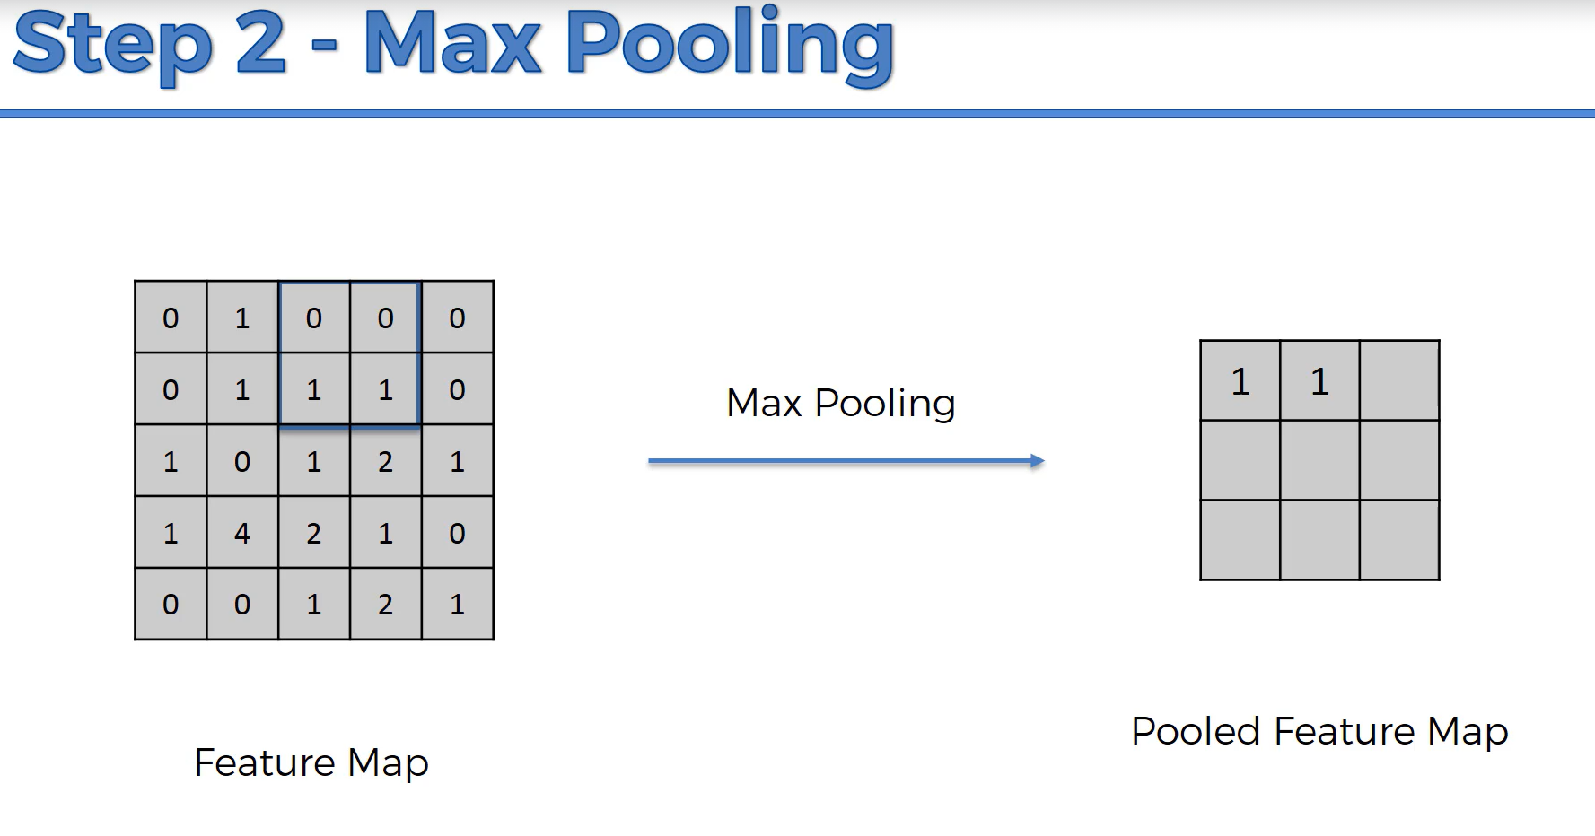

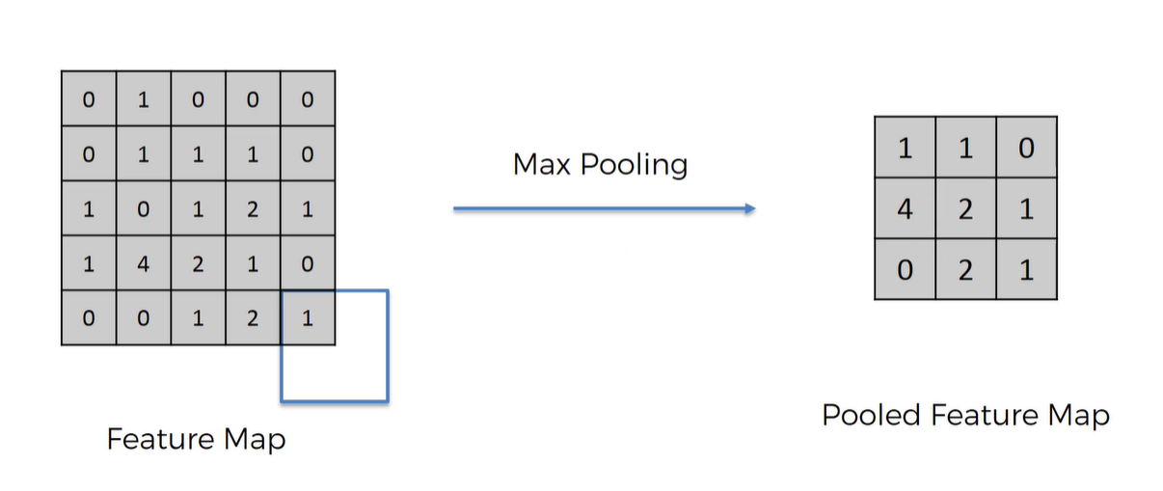



For example, if 4 resembles the “Tears” in a Cheetah’s eyes in one image, and then the “4” appeared in other location, then we will still have the same pooled map.